Dublin, Ireland, 27 January 2020.
Letter addressed to:
Iván Duque, President of the Republic of Colombia
Patricia Linares Prieto, President of the Jurisdicción Especial para la Paz
Margarita Cabello Blanco, Minister of de Justice and Law
Nancy Patricia Gutiérrez Castañeda, Interior Minister
Claudia Blum, Minister of Foreign Affairs
Carlos Alfonso Negret Mosquera, Ombudsman
Fabio Espitia Garzón, Public Prosecutor of the Nation
Fernando Carrillo Flórez, Attorney General
Pablo Elías González Monguí, Director of the National Protection Unit.

Dear Madams/Sirs,
We are writing to you to express our deep concern for social leaders from indigenous Wayúu, Afro-descendant and campesino communities in La Guajira, who have been receiving serious threats against their persons for years, and who in the past months have seen a rise in said threats.
There are several people affected, and amongst them we would like to mention a few specific cases, all of persons who have received threatening messages and phone calls, as well as in some cases physical aggressions against their persons.
- Ines Estela Pérez Arregoces, who asked the UNP (National Protection Unit) for protection last year after her name appeared in a threatening pamphlet from the Águilas Negras (Black Eagles paramilitary group). She has been interviewed by a UNP representative, but has received no decision, and this slow process is leaving her in a situation of extreme risk.
- Jairo Dionisio Fuentes Epiayu, cabildo gobernador of the community Tamaquito II, who received a bulletproof vest from the UNP in 2012 but was denied a protection scheme in the decision on his application to the UNP in 2018. His social work in ethnic communities leaves him very exposed to risks.
- Samuel Arregoces, who has made formal complaints to the UNP and other authorities about several threats to his person, and in 2019 received a bulletproof vest, panic button and cell phone from the UNP, which are not sufficient protective measures for the gravity of the threats.
- María Cristina Figueroa Bouriyu from the community Provincial, who had an inadequate protection scheme from the UNP that was removed last year, with no offer of an alternative.
- Luz Angela Uriana Epiayu from the community Provincial
- Blas y Leobardo Sierra from the community El Rocío
- José Gil from the community Charito
- Jakeline Romero Epiayu, Jazmín Romero Epiayu, Luis Misael Socarras, Karmen Ramírez, Miguel Iván Ramírez, Deris Paz, Dulcy Cotes, Evelin Acosta y Angélica Ortiz from the organisation Fuerza de Mujeres Wayúu (Wayúu Women’s Force), an organisation that has received several threats that mention the names of specific members.
- Alvaro Ipuana, who after an international trip to speak about the impacts of Cerrejón, received several threats. He has UNP protection.
- Carlos Ramirez Uriana, from the Resguardo Mayabangloma.

Below we copy some examples of the threats that these leaders receive:
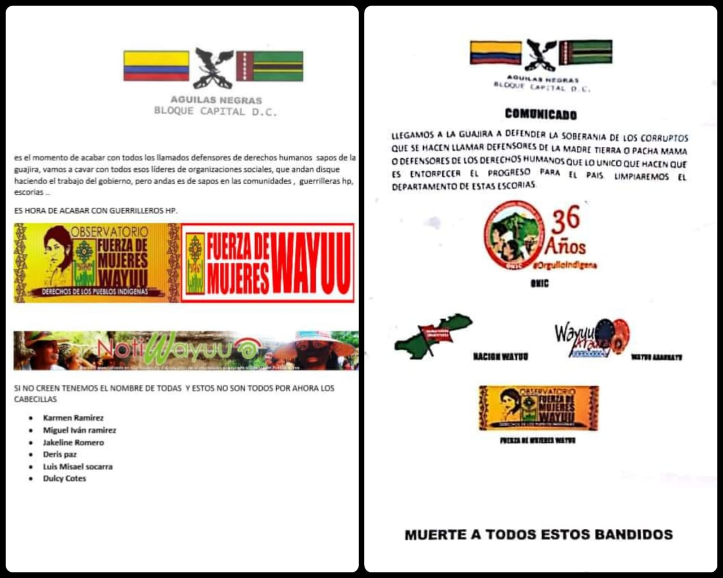
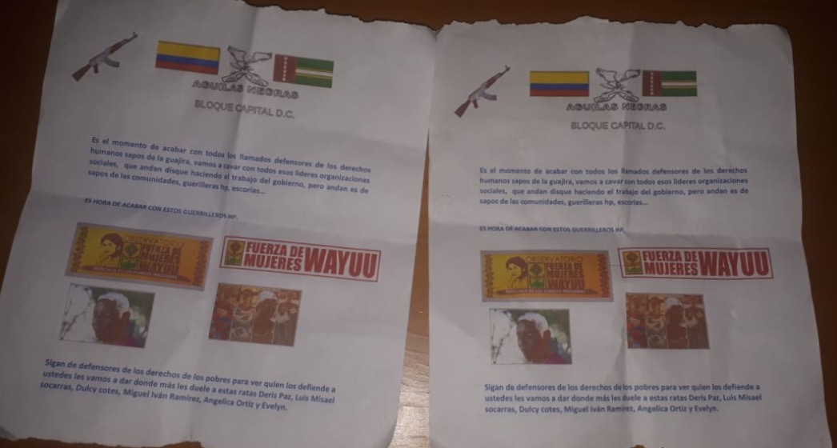

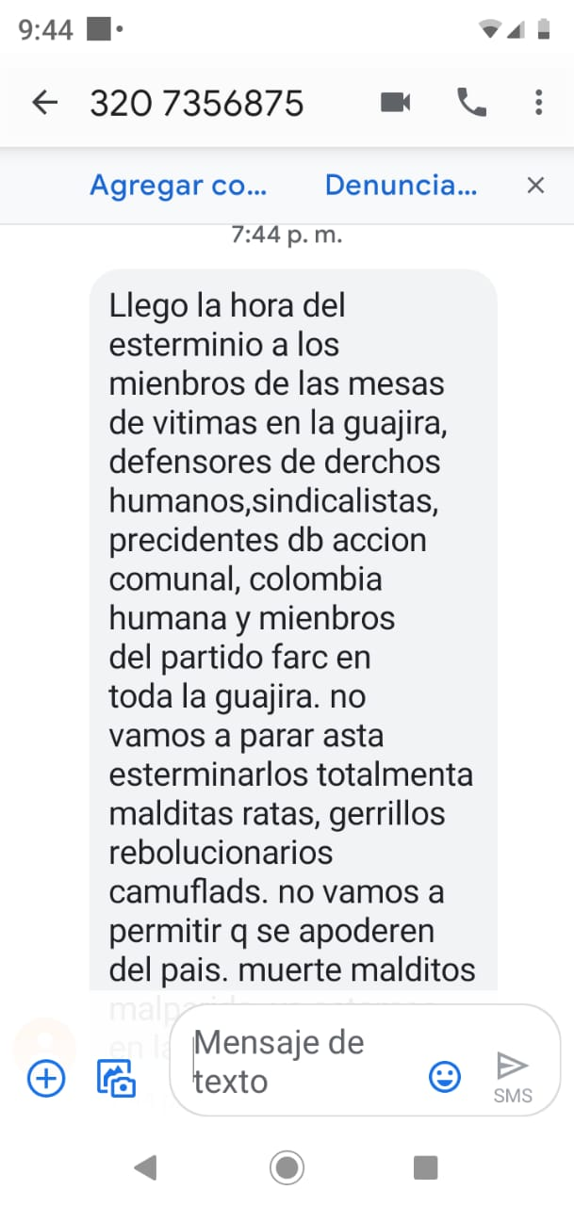

It is evident for us that these social leaders carry out very important work in Wayúu, Afro-descendant and campesino communities in La Guajira. And it is also evident that their work in communities causes much personal insecurity for them and their families.
We express our deep concern for the security of these leaders, and we call on the UNP and other responsible authorities to provide adequate and sufficient measures for their protection. We also urge the authorities to re-evaluate the protective measures that the UNP provides to some leaders in La Guajira and to ensure that they provide these measures according to the community and cultural needs of the leaders.
We call for immediate and exhaustive investigation into those responsible for the threats by the Public Prosecutor and other responsible authorities. We demand action from the authorities to put an end to the operations of illegal and violent groups in La Guajira.
If we can be of assistance in any regard, please do not hesitate to contact us.
Yours Sincerely,
Organisations:

- Stop Blood Coal Ireland
- Latin America Solidarity Centre, Ireland
- Coal Action Network, UK
- Colombia Solidarity Campaign, UK
- London Mining Network, UK
- kolko - Menschenrechte für Kolumbien e.V., Germany
- ABColombia, UK
- pax christi - Comisión Solidaridad Un Mundo, Germany
- Swiss Working group on Colombia/Grupo de Trabajo Suiza Colombia ask!
- EcoMujer e.V.
- Indepaz - Colombia
- United Migrant Workers Education programme
- The Democracy Center

Individuales:

- Jacqueline Gilbert
- Paul Dowling
- Emma Banks, Vanderbilt University
- Aviva Chomsky, Salem State University
- Noel Healy, Associate Professor Salem State University

